SPECIMEN INVITATION – Paper voucher
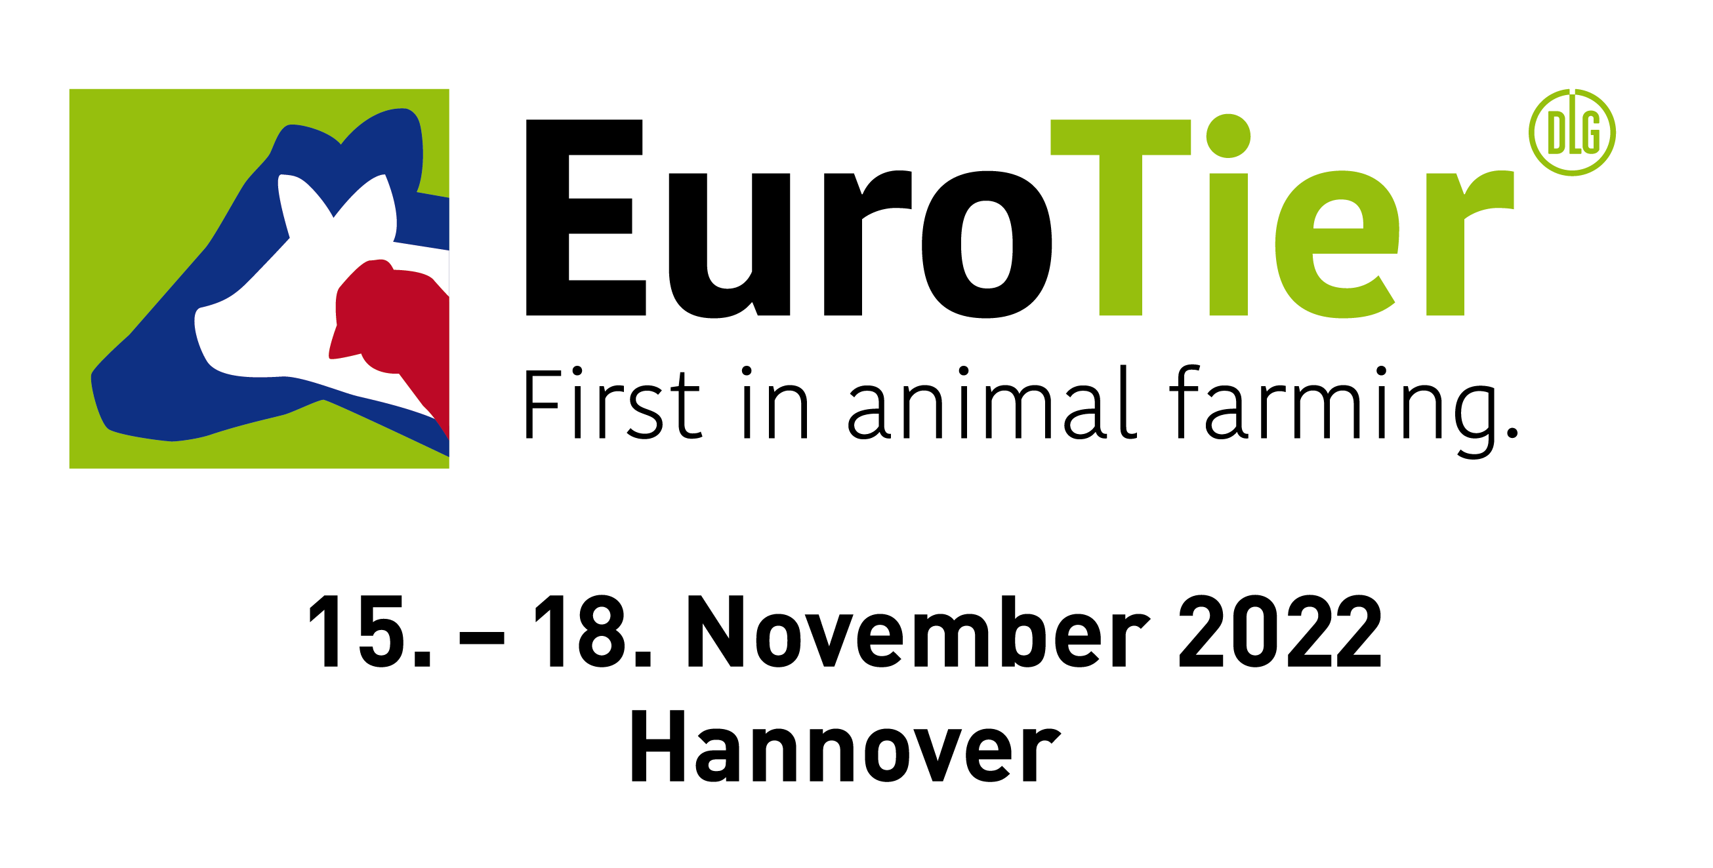

Address of your customer

28/06/2022

Invitation to EuroTier 2022

Dear customer,
We would like to invite you to EuroTier, the world’s leading trade fair for animal production, which will be held from 15 to 18 November 2022 in Hanover, Germany.
Visit us in on Stand x.
Enclosed please find a voucher from us that you can convert online into a personal admission ticket.
Important! The voucher itself is not a ticket and does not grant admission. You need to register online to obtain your personal admission ticket.
Redeeming your voucher – what to do:
1) Go online to www.eurotier.com/registration
2) Enter your voucher code and register online
3) Print out your e-ticket or save it on your smartphone
If you have any questions about the registration, you can contact the EuroTier-Team directly, by e-mail to ticketing@dlg.org or by telephone at +49 69 24788-425.
We look forward to seeing you there!
Kind regards,

PS: All the information about redeeming your voucher is shown on the back of your voucher too.

